Comparing Physics Informed Neural Network (PINN) with Neural Network (NN) for Modelling Corn Bag Motion

Introduction
In this work, the experimental data as shown in Figure 1, obtained during the project for corn bag projectile motion have been used to study the capability of NN and PINN in capturing the underlying behavior of this bag during its motion.
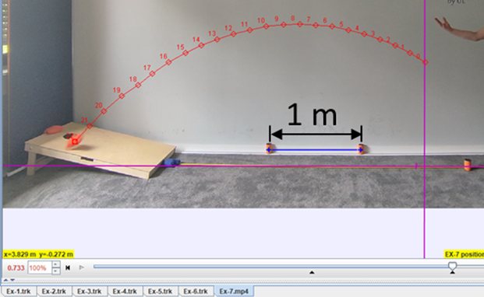
Figure 1: The Experimental Data obtained during Isento Project

Data Preparation
Two players have played the corn hole game, and the data captured will be used for the training of both the NN and the PINN. The whole data is composed of nine sets, where each set represents a trial, however, each point in each set is a separate data point which is composed of five parameters [Initial Velocity (m/s), Initial Angle (rad), Initial Height (m), Horizontal Displacement (m), Vertical Displacement (m)]. The Training set will be composed of six trials, while the Test set will be composed of three as shown in Figure 2.
Figure 2: The Data Set "a" is the Training data composed of 135 data points, and the Test data set "b" is composed of 71 data points. In this figure, x is the horizontal displacement in meters, and y is the vertical displacement in meters.

The Neural Network Architecture
A Neural Network Architecture as shown in Figure 3 has been developed, which is composed of two hidden layers with 8 neurons each. The input layer compromises the four inputs to this model, which are: the initial velocity in m/s, the initial angle in radians, the initial height in meters, and the horizontal displacement in meters. The output layer is the vertical displacement in meters.
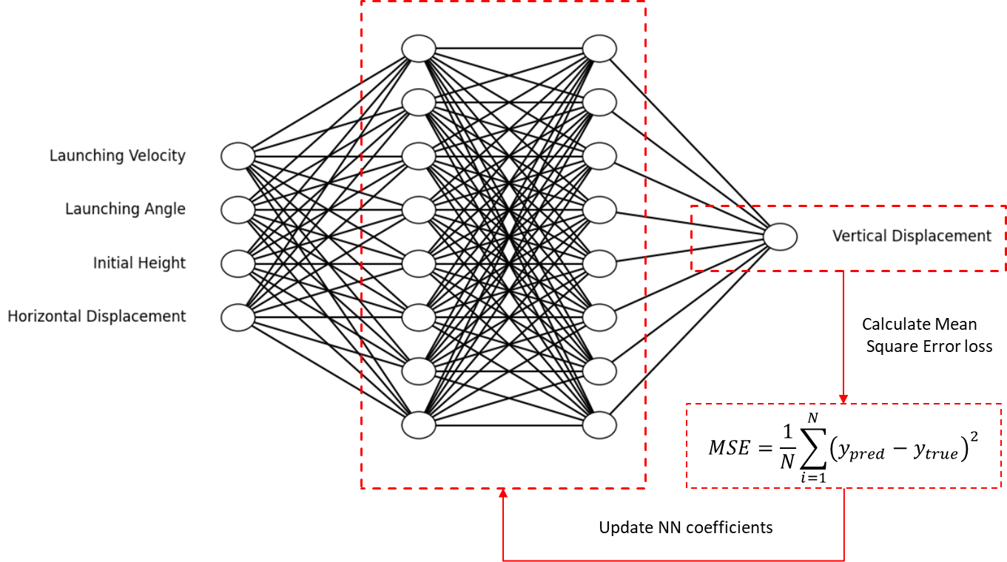
Figure 3: The Neural Network Architecture
This NN architecture of using multiple layers of equal neurons follows the work done by (Michek, Mehta, and Huebsch 2023), also the activation function used is ‘softplus’ following the same work. The number of trainable coefficients in this architecture is 104 coefficients, which is less than the data used. Although it is slightly recommended in (Duda 2001) that the number of coefficients ≈ n/10, where n is the number of data points available for training the NN model, it is strictly mentioned that the number of coefficients should be less than the number of data points.

Training the NN and Perform Error Analysis
The training of this NN on the data set Figure 2 (a) has been performed first in a loop of ten trials with 6000 epochs each, to decide the optimum number of epochs. The decision for this optimum in every trial should be based on the point where the test error reaches its minimum before it starts increasing as the training continues as shown in Figure 4 (Duda 2001). Similar behavior has been encountered during training of the NN model as shown in Figure 5, whereas the epochs increase the training error has a tendency to saturate or slightly decrease while the test error starts to increase, this behavior means that the model is overfitting the training data. The fluctuation of the optimum number of epochs for the NN is shown in Figure 6. Although the fluctuation shown in Figure 6 is significant, the effect on the training error is not significant, as shown in Figure 5, the Training Error is between 0.75% and 0.25 %, which is considered to be an acceptable error. Thus, the optimum that will be used for training the NN model is the average of all optimum values, which is 3722 epochs.

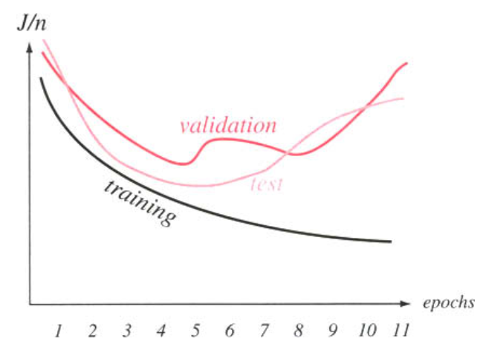
Figure 4: The Behavior of different Error types during the training process, J/n is the mean of error over data set size.
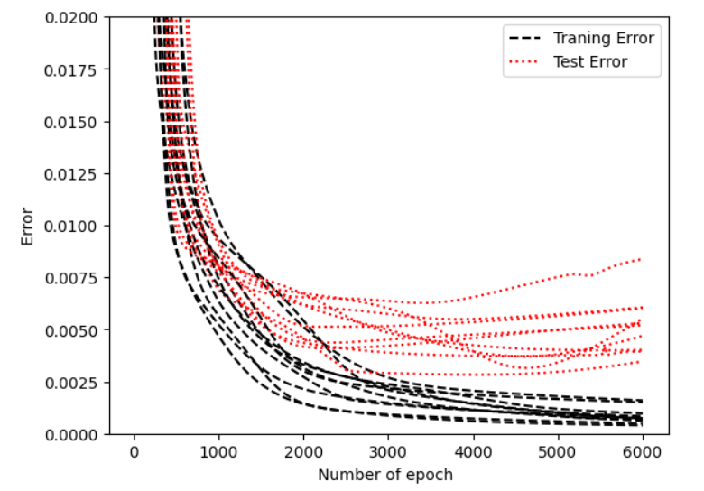
Figure 5: The Behavior of Training Error and Test Error during Training Process. The Error is the mean square error. Each line corresponds to one of the trials.
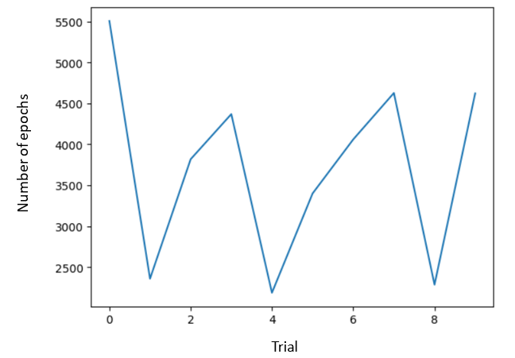
Figure 6: The optimum number of epochs for each trial.
The training of this NN model has been done using the optimum number of epochs 3722, and the behavior of the error during the training is shown in Figure 7. As shown in this figure, the training error is almost 0.15 % while the test error is almost 0.4% which shows that this model has been trained to high accuracy.
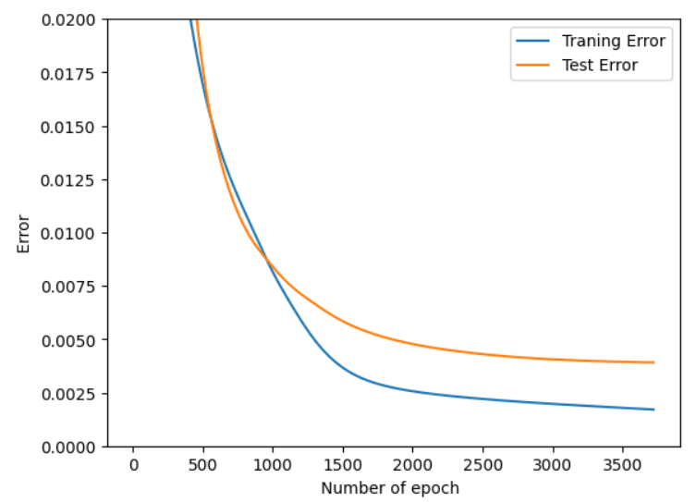
Figure 7: The Error behavior during training the NN model using the optimum number of epochs

Results and Discussion
The prediction of this model has been plotted concerning the data for the training data and the test data as shown in Figure 8. The Mean Square Error (MSE) between the data and the NN model prediction is shown in Figure 9.
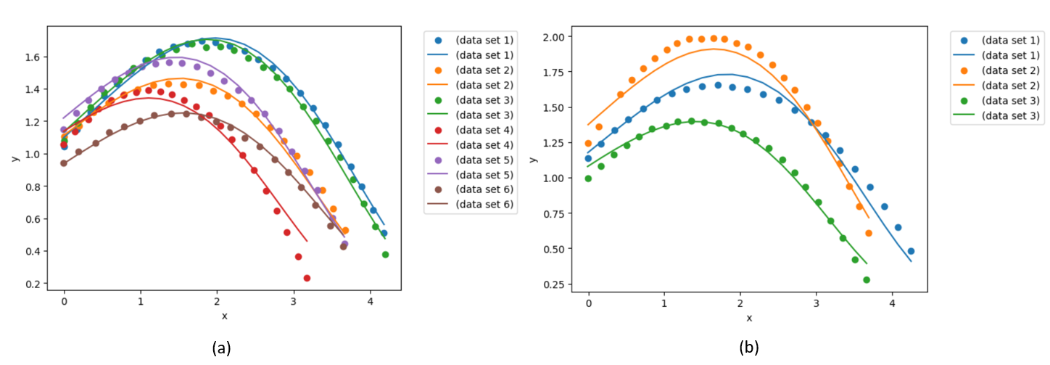
Figure 8: Comparing the NN model prediction with the training data (a) and the test data (b). The solid lines are for the model predictions while the scatters are for the data sets.
Although these results show that the NN model was able to capture the data behavior for the corn bag motion with high accuracy, it is believed that this may be a drawback of the current NN model as the experimental data measurements contain measurement errors. In this situation, the experimental data need to be compared with the projectile motion model given by,
$$y=y_{o}+x×\tan{θ_{o}-\frac{g×x^{2}}{2×v_{°}^{2}×\cos^{2}{θ_{o}^{2}}}}$$where the $y$ is the vertical displacement, $y_{o}$ is the initial height, $g$ is the gravitational constant, $x$ is the horizontal displacement,${ θ}_{o}$ is the initial angle, and $v_{o}$ is the initial velocity. All the units are SI units.
The comparison between the physical model and the experimental data is shown in Figure 10. As is expected there is a deviation between the experimental data and the theoretical model, this deviation is owing to that the theoretical model did not capture all influencing factors, also it owing to that the experimental data has measurement errors. In the current work estimating the error in the experimental measurements is not possible, as the experiments are based on human factors and that is difficult to reproduce.
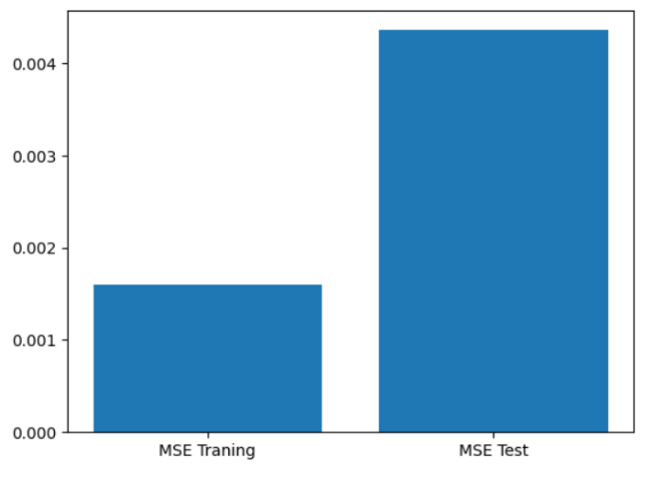
Figure 9: MSE between the experimental data and the NN model prediction.
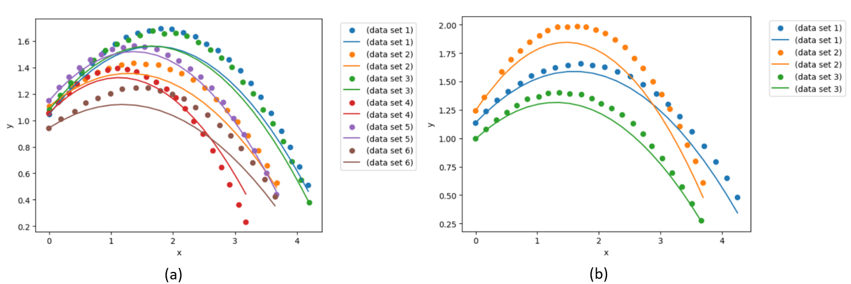
Figure 10: Comparing the theoretical model with the experimental data. The comparison concerning the training data set (a), and for the test data set (b).
To have a trustworthy NN model, its prediction should be compared to experimental data and to the theoretical model. The comparison between the error from the NN model predictions and the theoretical model predictions with the error from the NN model predictions and experimental data is shown in Figure 11. This comparison shows that the NN model is very close to the data as the MSE is almost 0.5 %, while the theoretical model MSE is almost 2.5 %. Thus, the MSE from the theoretical model is 5 the MSE of experimental data.
In this situation, it is suggested that a Physical Informed Neural Network model be used, to minimize both the physical error and the neural network error, which could produce trustworthy predictions. This will be discussed in the next section.
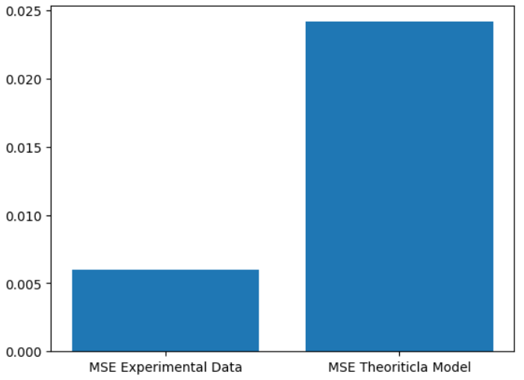
Figure 11: Comparing MSE between the NN model and experimental data with MSE between the NN model and the physical model.

The Physical Informed Neural Network (PINN) Architecture
A PINN Architecture as shown in Figure 12 has been developed, the neural network structure is the same as described in the previous section. In this PINN the MSE arises from the difference between the neural network model prediction and the theoretical prediction that has been considered. That is expected to develop a trustworthy PINN model. The projectile motion model described in the previous section will be used in the calculation of physical loss.
It is important to note that, although the physical term has been used in the loss calculation, the training error and the test error which has been used after finishing and developing the PINN model, which is used in error analysis, are based on the error calculation between the PINN model and the experimental data, without including the error calculations between the PINN model and physical model. This has been decided to have consistency regarding the terminologies used in this report, also because the training data and test data are only experimental, and no theoretical data have been used during the training of the PINN model.
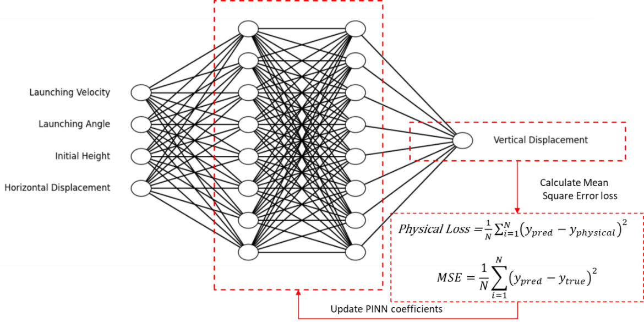
Figure 12: The Physical Informed Neural Network Architecture

Training the PINN and Perform Error Analysis
The Training of this PINN on the data set Figure 2 (a) has been performed first in a loop of ten trials with 6000 epochs each, to decide the optimum number of epochs. The decision for this optimum in every trial should be based on the point where the Test Error reaches its minimum before it starts increasing as the training continues as shown in Figure 4(Duda 2001). However, in this PINN model, there are higher fluctuations without significant changes in the error after 3000 epochs as shown in Figure 13.
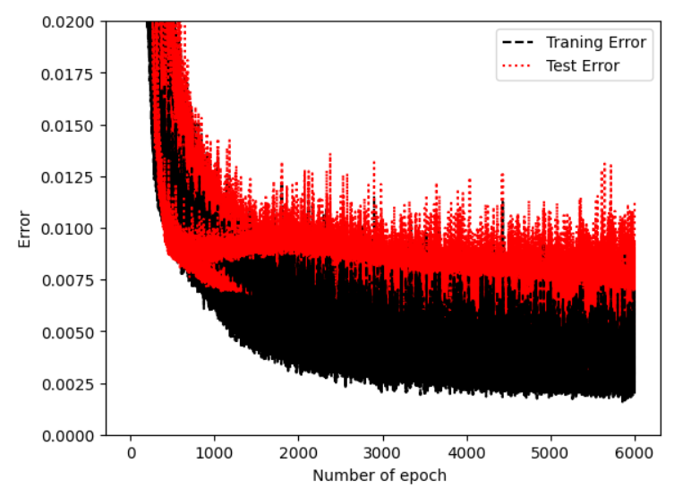
Figure 13: The Behavior of Training Error and Test Error during the Training Process for the PINN model. The Error is the mean square error. Each line corresponds to one of the trials.
The training of this PINN model has been done using the number of epochs 3000, and the behavior of the error during the training is shown in Figure 14. As shown in this figure, the training error is almost 0.5% while the test error is almost 0.75% which shows that this model has been trained to high accuracy.
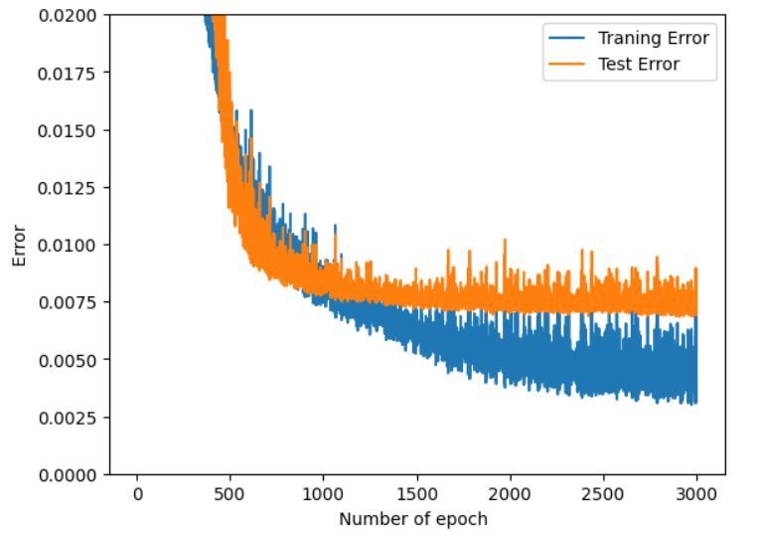
Figure 14: The Error behavior during training of the PINN model.

Furthermore, the behavior during the training process of PINN regarding the MSE for experimental data (between experimental data and PINN model) and the MSE for the physical term (between physical term and PINN model) is shown in Figure 15. This representation shows that both terms have been almost equally included and represented in the loss function for the PINN model.
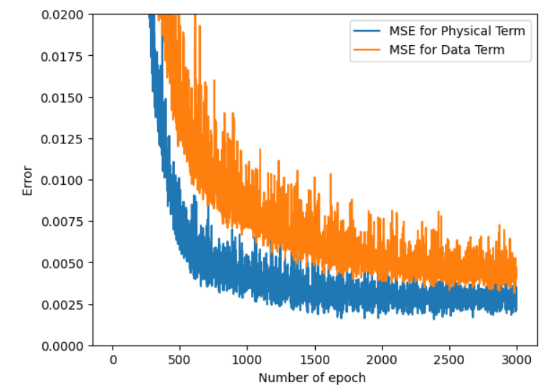
Figure 15: the behavior of MSE for data (between data and PINN model) and the MSE for physical term (between physical term and PINN model) is shown

Results and Discussion
The prediction of this PINN model has been plotted concerning the data for the training data and the test data as shown in Figure 16. The Mean Square Error (MSE) between the data and the PINN model prediction is shown in Figure 17.
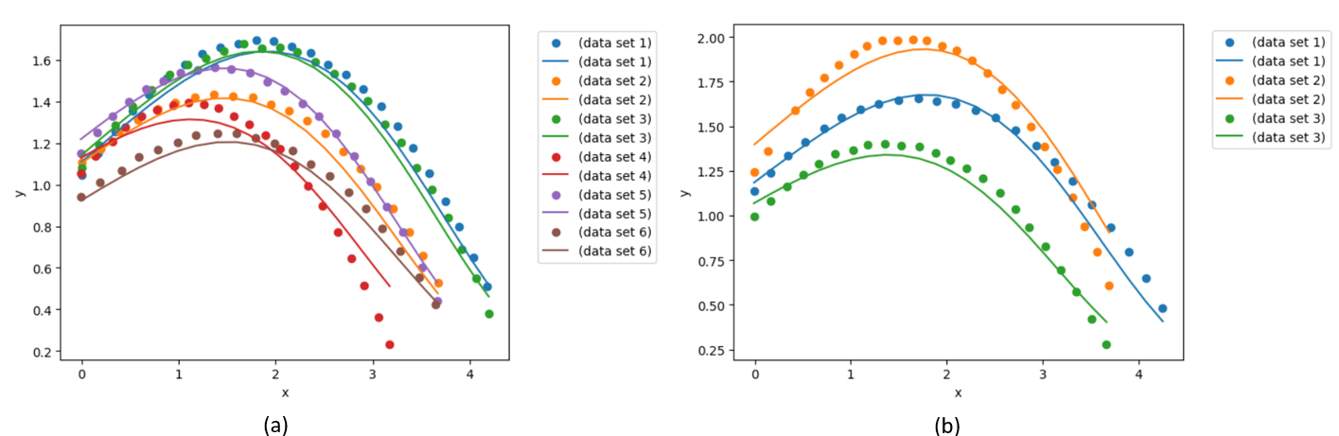
Figure 16: Comparing the PINN model prediction with the training data (a) and the test data (b). The solid lines are for the model predictions while the scatters are for the data sets.
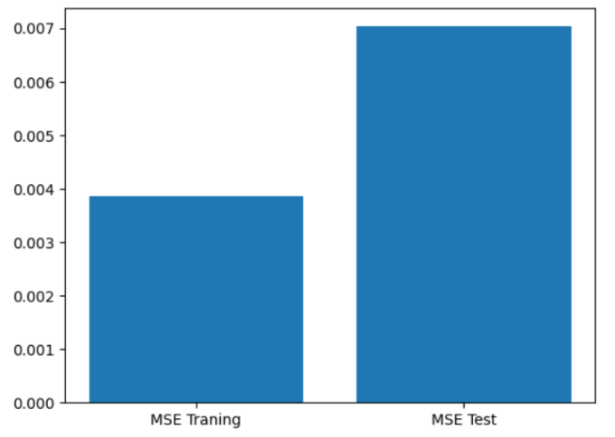
Figure 17: MSE between the experimental data and the PINN model prediction.
The comparison between MSE error between the PINN model predictions and the theoretical model predictions with the error between the PINN model predictions and experimental data is shown in Figure 18. This comparison shows that the PINN model is very close to the data as the MSE Experimental Data is almost 1 %, while the MSE theoretical model is almost 2 %. Thus, the MSE from the theoretical model is almost double the MSE from the experimental data. Comparing to NN model predictions Figure 11, the PINN model has reduced the gap between the MSE error between the PINN model predictions and the theoretical model predictions and the MSE error between the PINN model predictions and experimental data.
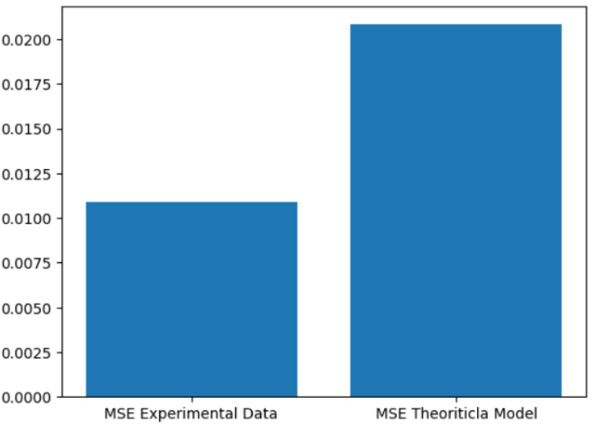
Figure 18: Comparing MSE between the PINN model and the physical model.
- Summary and Conclusion
In this work, NN and PINN models have been developed to capture the motion of a corn bag. Both models have shown high capability in capturing the motion of corn bags. The MSE between the NN model and the experimental data is roughly 0.6 %, while it is roughly 0.12 % between the PINN model and experimental data. This, however, does not represent a deterioration in the prediction capabilities, but an improvement in the trustworthiness of the machine learning model. As the MSE between the NN model and the physical model is roughly 2.5 %, which is roughly five times its value between the NN model and experimental data. The MSE between the PINN model and the physical model is roughly 2 %, which is roughly double its value between the PINN model and experimental data. Thus, the PINN model has improved the capability of capturing also the physical model without much reduction in its capability to capture the experimental data.

5. References
Duda, Richard O. 2001. “Pattern Classification.”
Michek, Nathaniel, Piyush Mehta, and Wade Huebsch. 2023. “Methodology Development of a Free-Flight Parameter Estimation Technique Using Physics-Informed Neural Networks.” Pp. 1–18 in 2023 IEEE Aerospace Conference. Big Sky, MT, USA: IEEE.
https://www.tensorflow.org/tutorials/customization/custom_training_walkthrough

This refer to isento project, where isento is the company where the project of modeling the corn bag motion has started and it is aimed to be used for a robotic project, please refer to the folder “Isento-Project” for further information.

